Algebra 1: Unit 1, Lesson 1

- What function family does the equation $y=\sqrt[3]{x+1}$ belong to?

Cube Root

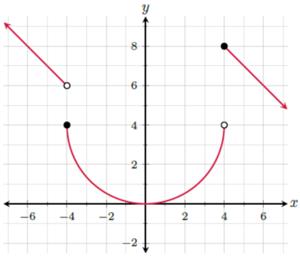

- Does the given graph represent a linear function or a non-linear function?

Non-linear

- Does the equation $y=3^{x}$ represent a linear function or a non-linear function?

Non-linear

